SI3 Analytics Dashboard Portfolio Report

Project Overview
SI3 Analytics Dashboard is a full-stack analytics platform for tracking LinkedIn growth and email campaign performance in one place. The project combines a Next.js frontend, an Express backend, MongoDB persistence, and Loops webhook integration to deliver a unified view of audience growth, email engagement, and campaign outcomes.

What The Project Does
- Visualizes LinkedIn content, follower, and visitor metrics from uploaded analytics exports.
- Displays email campaign performance, list growth, and top campaigns from Loops-driven data.
- Supports Excel file uploads for LinkedIn analytics ingestion.
- Exposes API routes for dashboard refresh, uploads, email analytics, and webhook processing.
- Includes a Dockerized deployment setup for local production-style runs.

Tech Stack
- Frontend: Next.js 14, React 18, TypeScript, Chart.js, CSS
- Backend: Node.js, Express, Mongoose, Multer, Axios
- Data: MongoDB, Excel/CSV imports, Loops API webhooks
- Deployment: Docker, Docker Compose

Key Features
- LinkedIn dashboard with KPI cards, trend charts, and top-performing campaign summaries.
- Email analytics view with open rate, click rate, delivery rate, bounce rate, unsubscribe rate, and list growth tracking.
- File upload workflow for LinkedIn exports.
- Webhook-driven email event capture and campaign statistics.
- Responsive dark UI with branded gradient styling.

Architecture
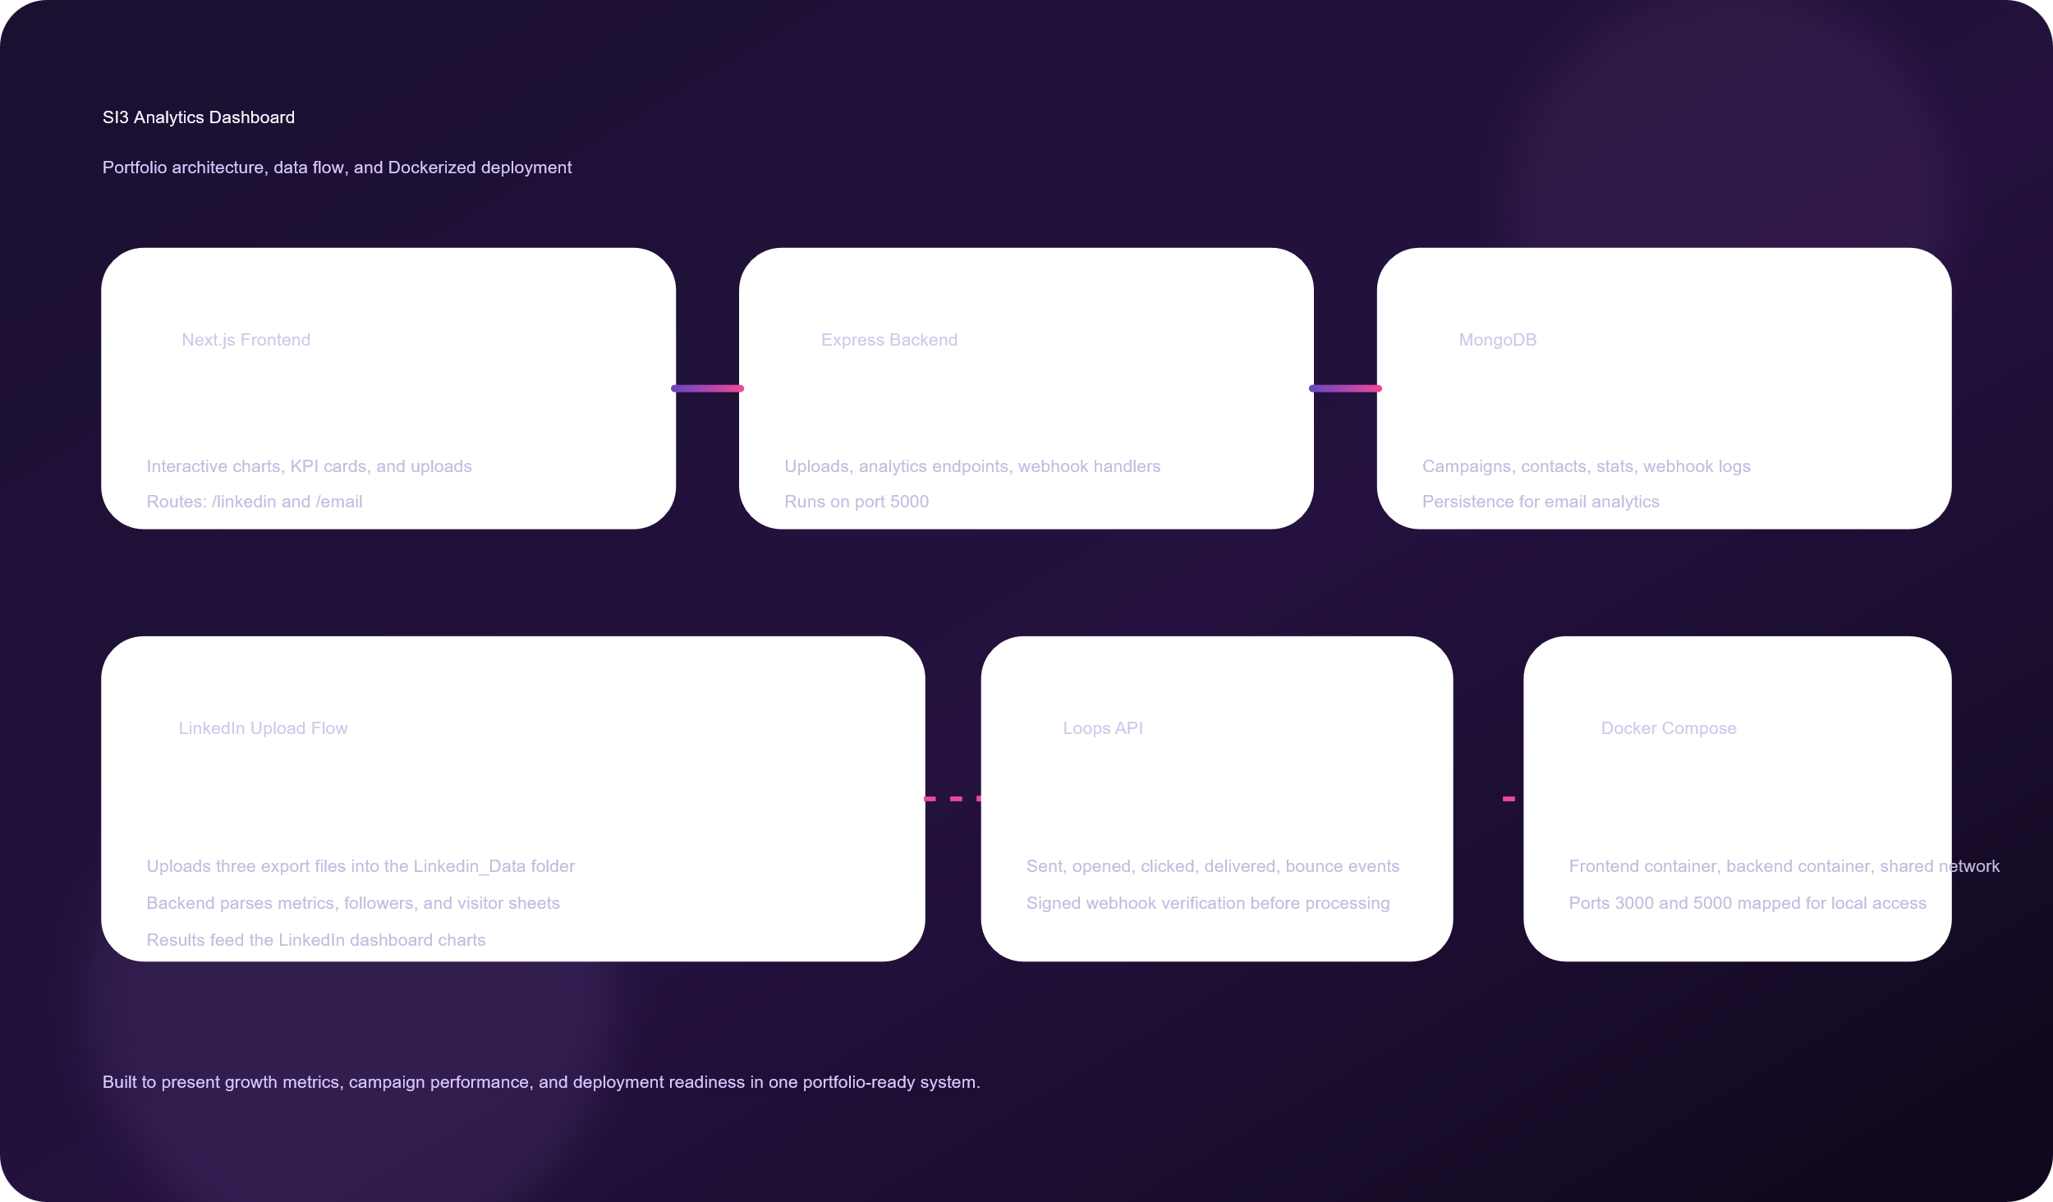
The frontend reads from the backend API. The backend loads LinkedIn exports from the local data folder, stores email events and campaign data in MongoDB, and processes Loops webhooks for live email analytics.

Dockerization Done
The project is container-ready and split into two services:
- Frontend container built from [client/Dockerfile](client/Dockerfile)
- Backend container built from [server/Dockerfile](server/Dockerfile)
- Multi-service orchestration defined in [docker-compose.yml](docker-compose.yml)

This setup exposes the app on ports 3000 and 5000, passes the required environment variables into each service, and mounts the LinkedIn upload directory so imported files persist across runs.

Output Images
The repository already includes the main brand assets used by the dashboard:
- LinkedIn Dashbaord
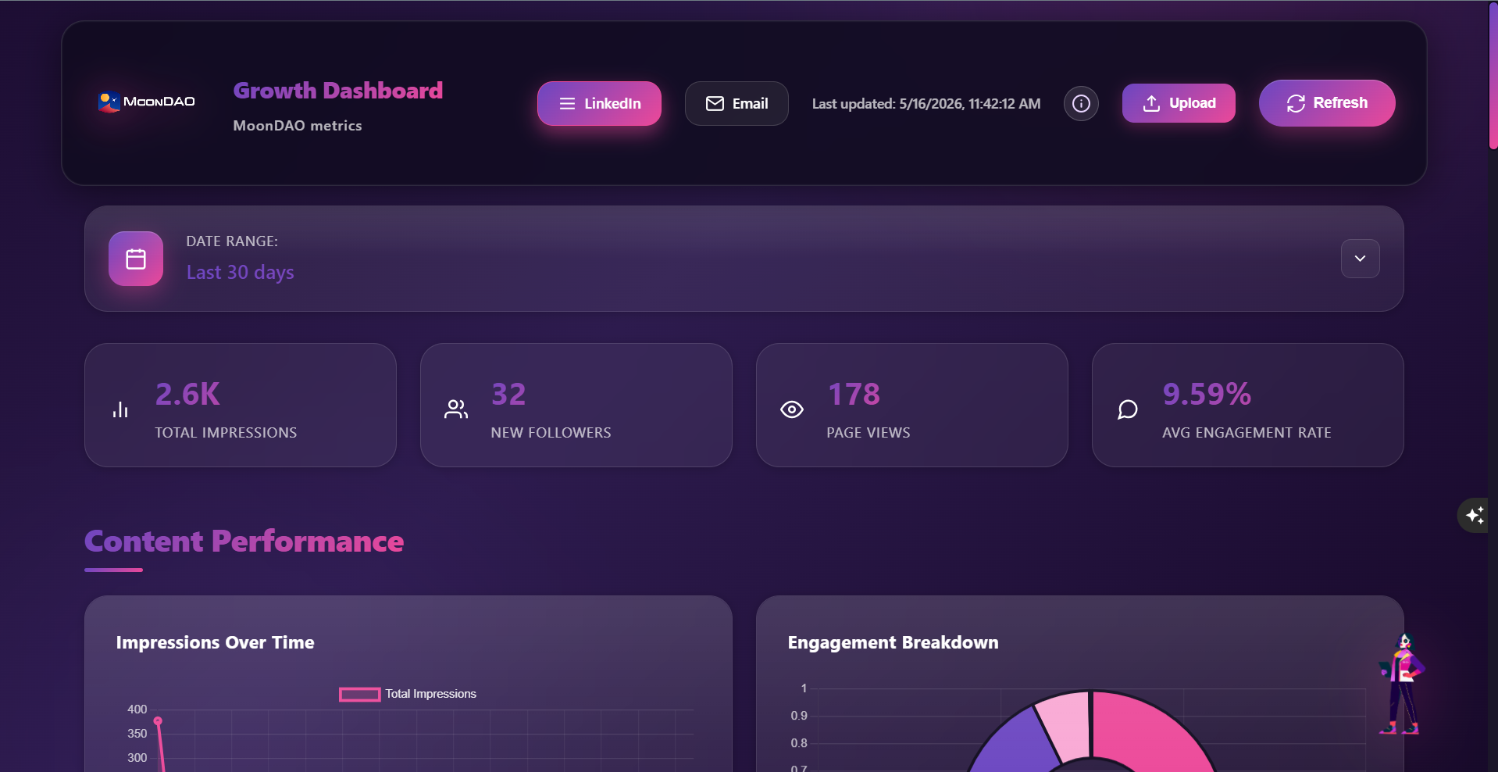
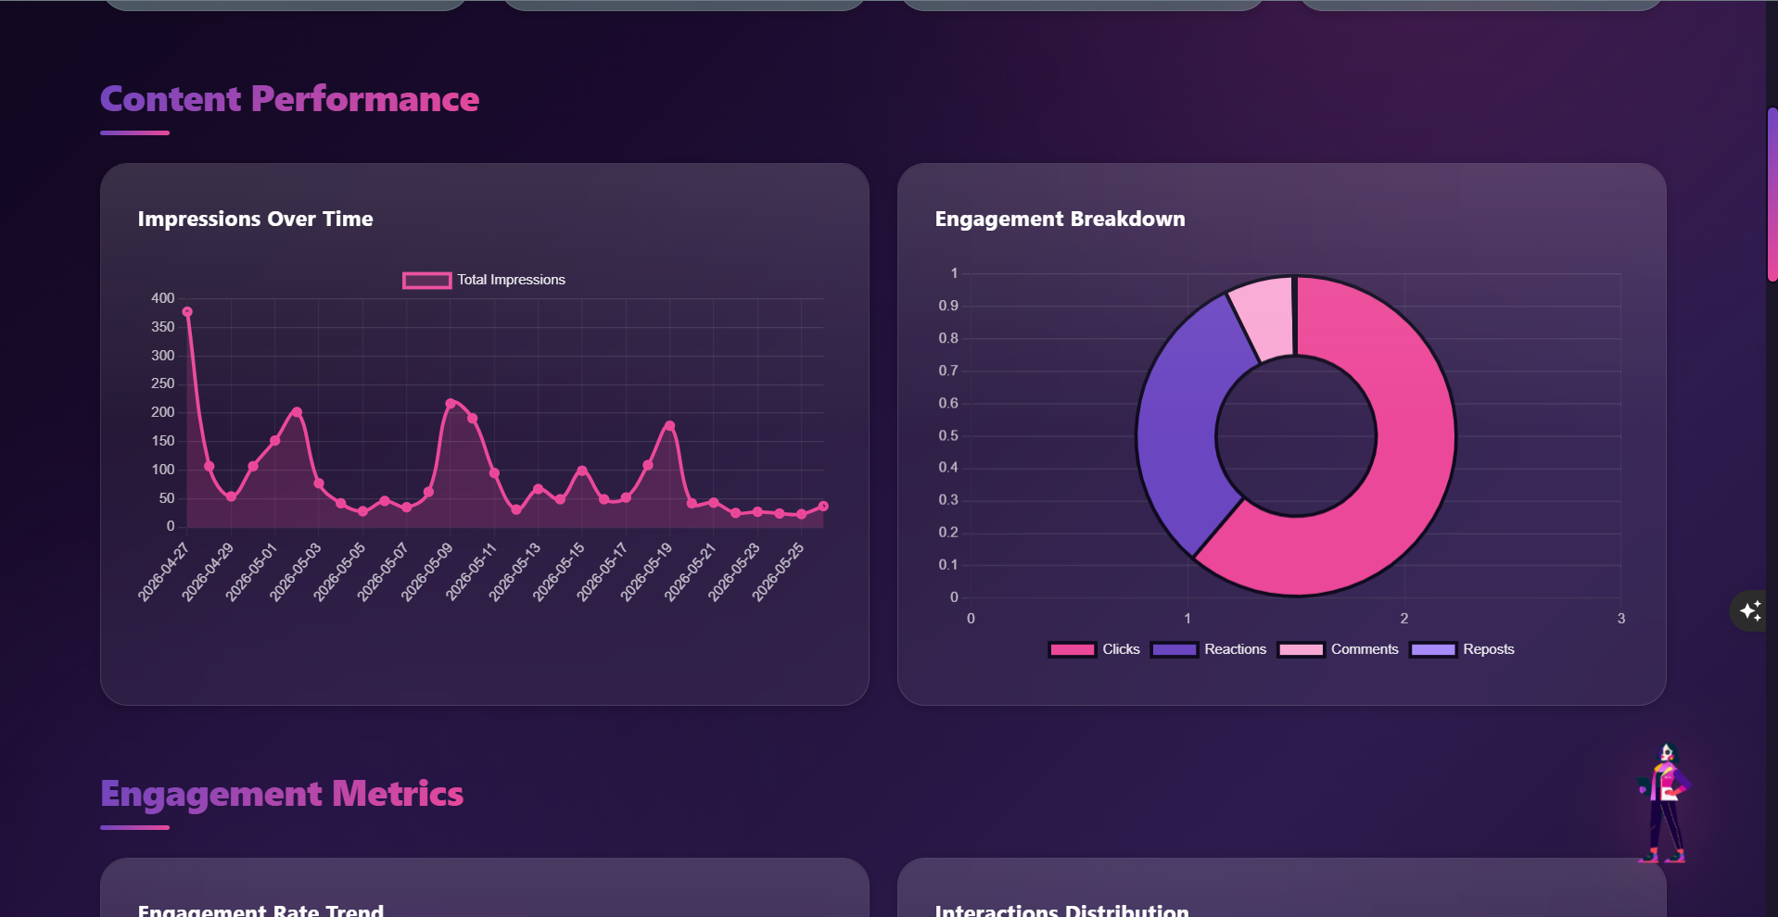
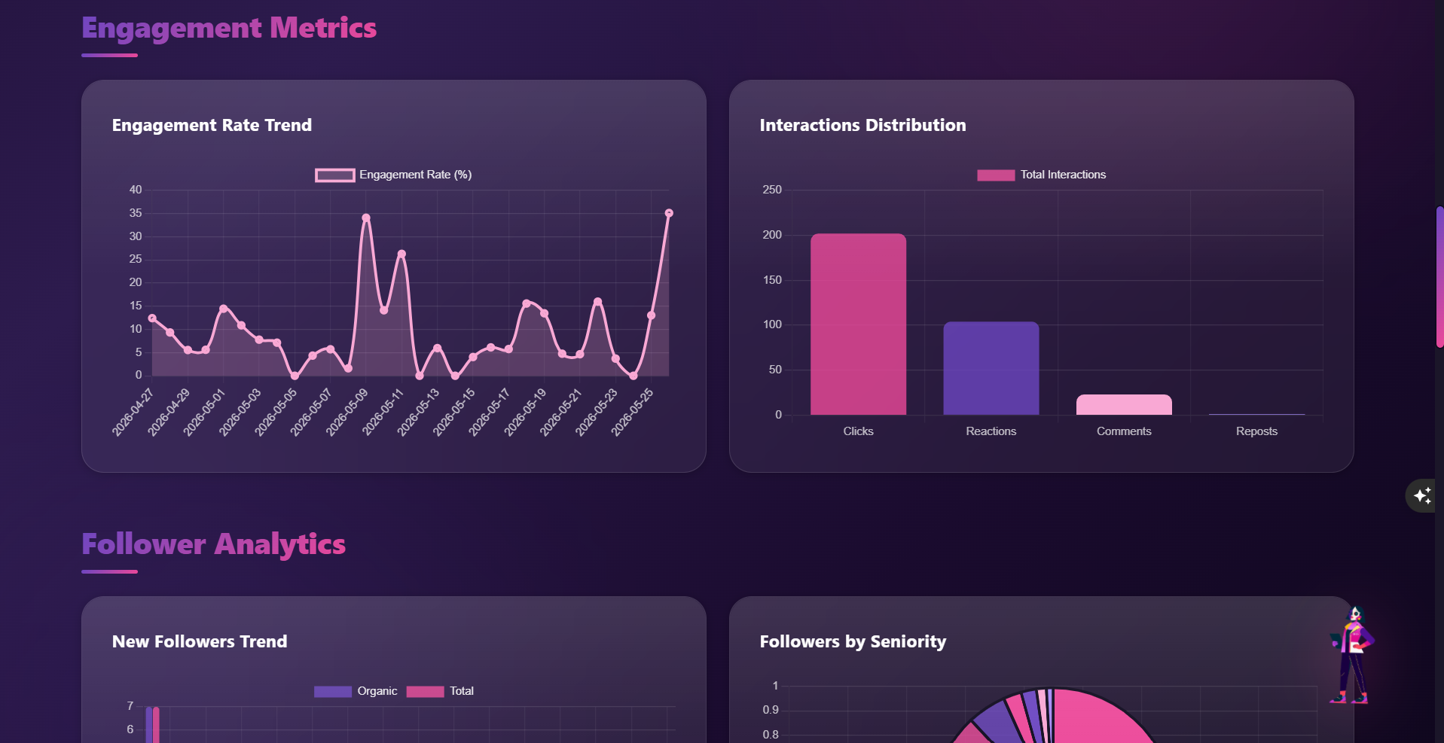
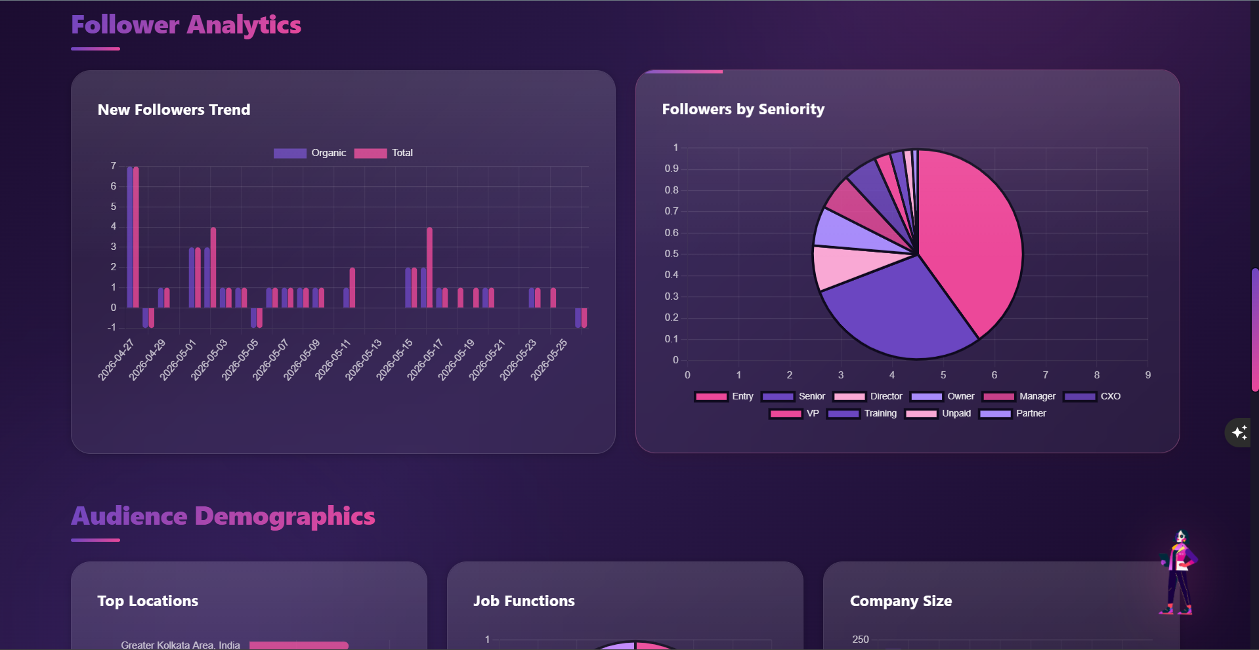
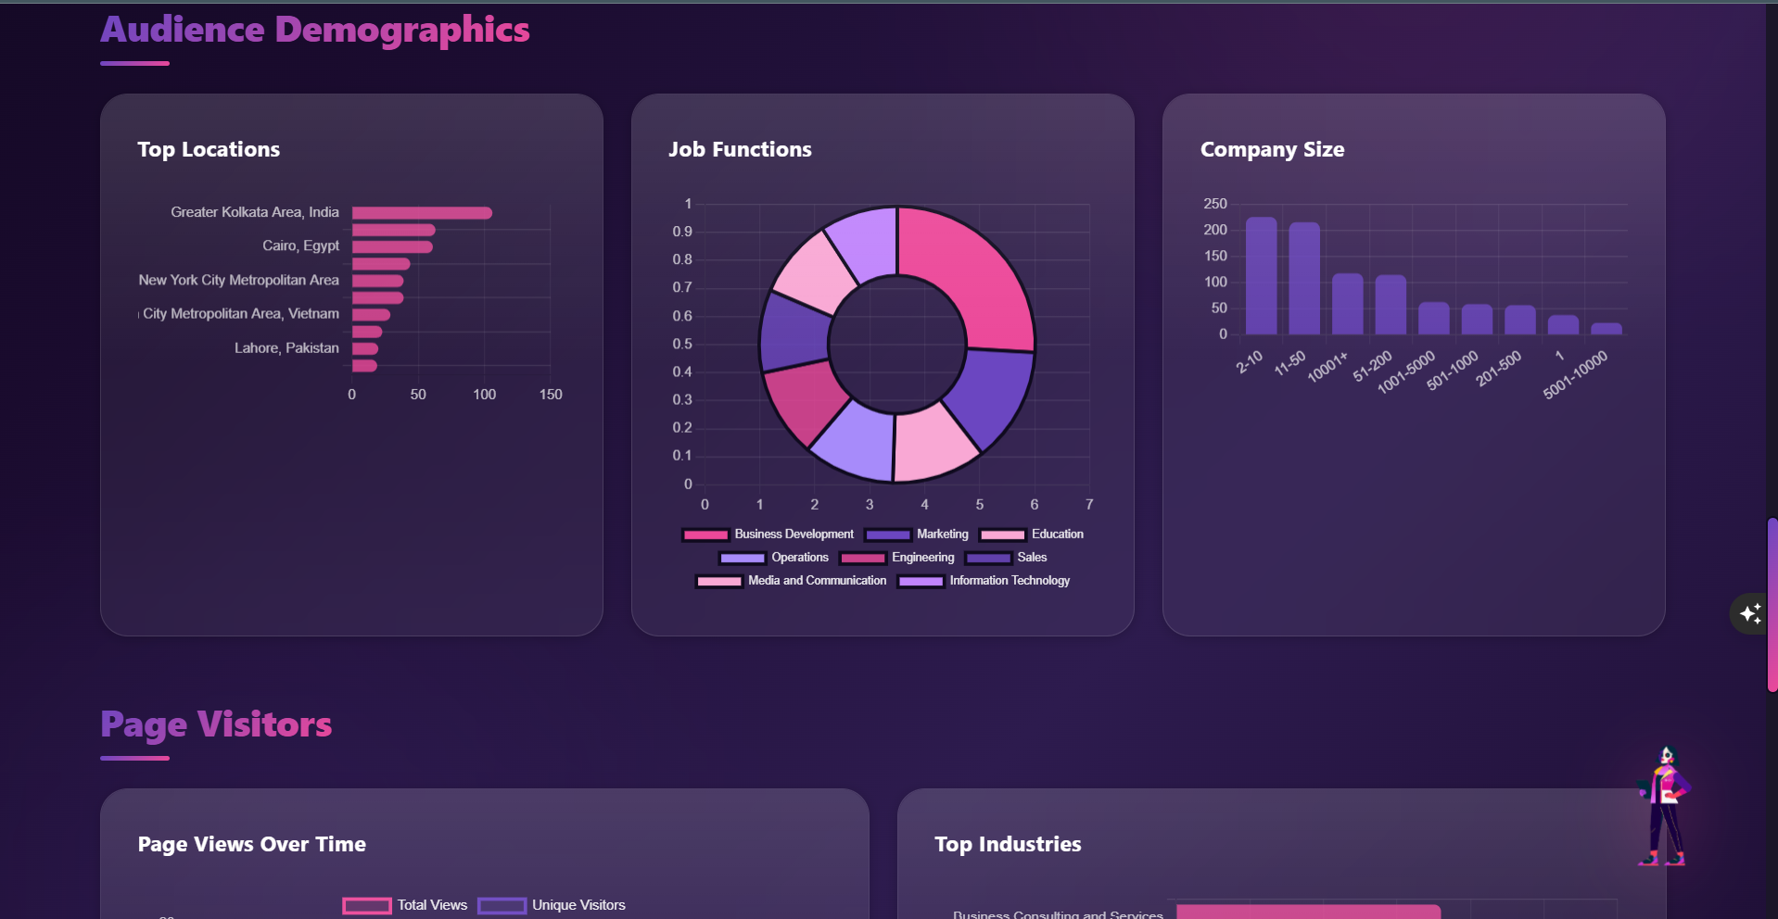
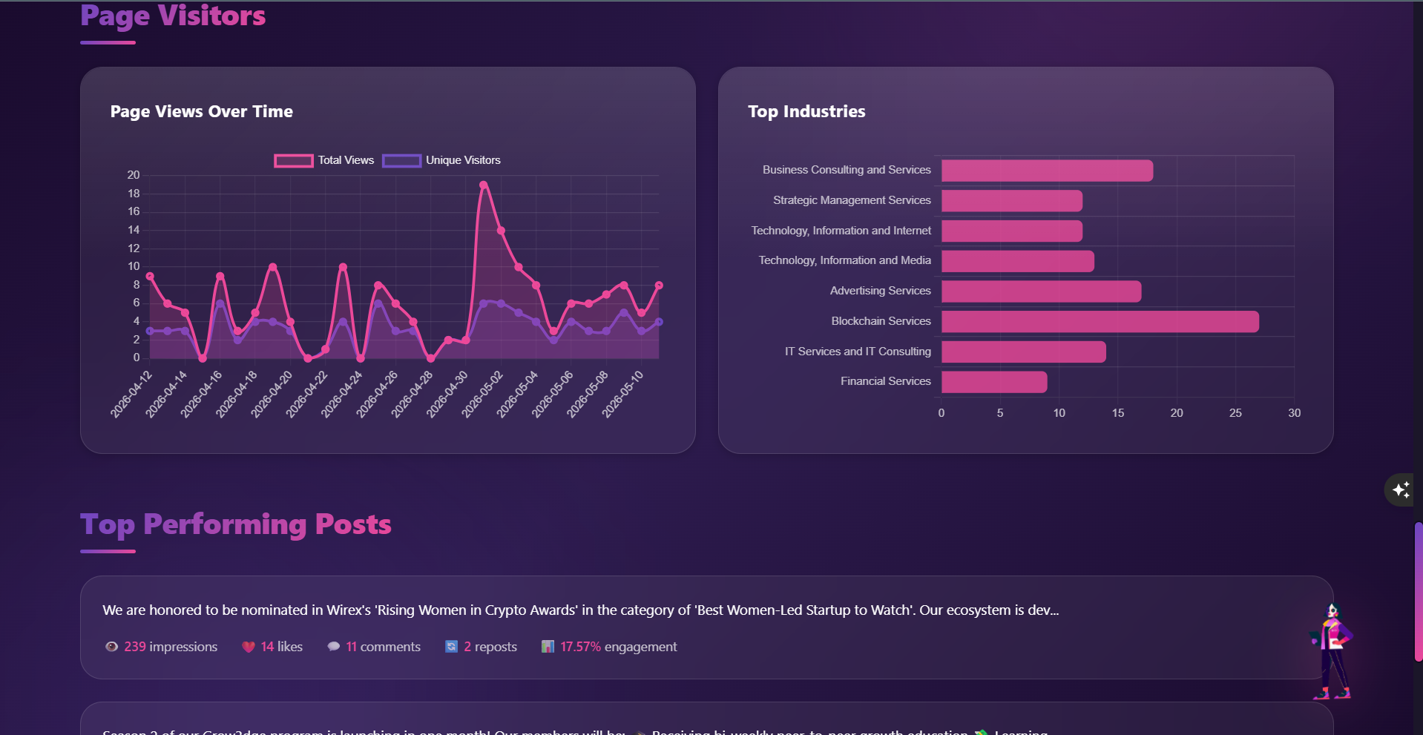

- Email
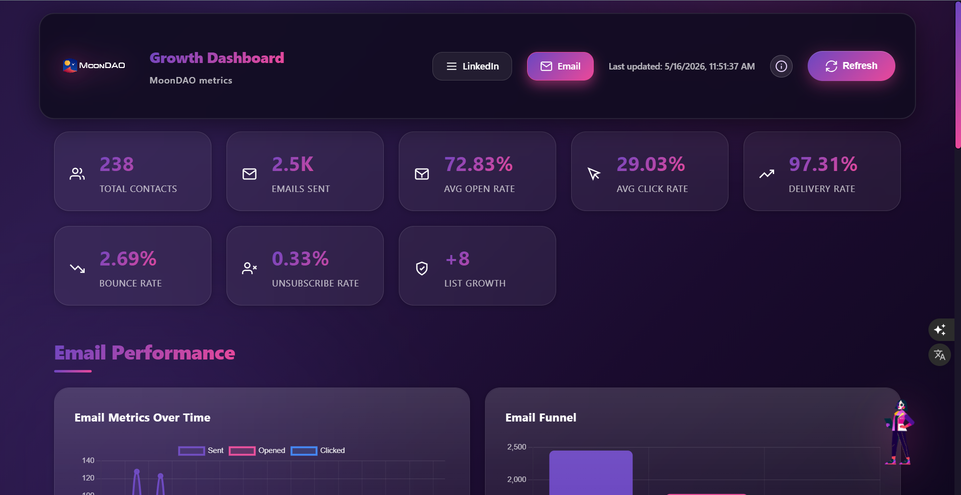
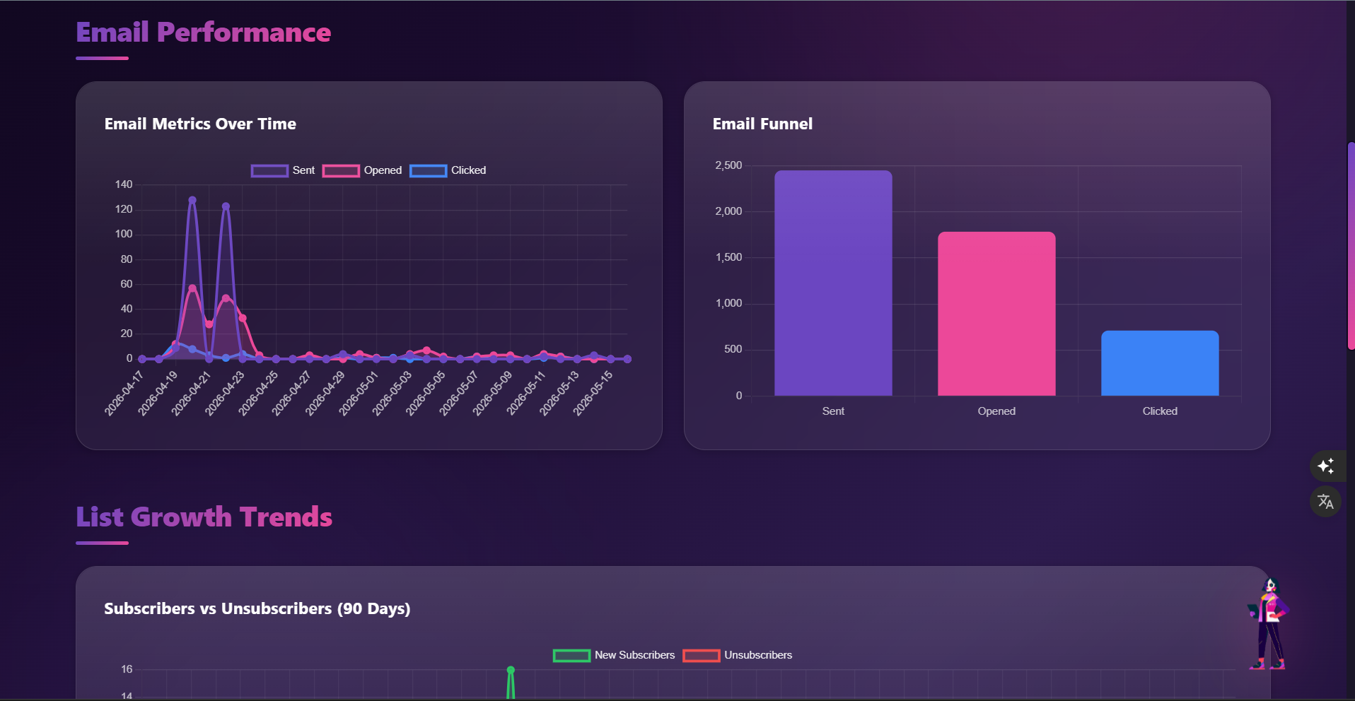
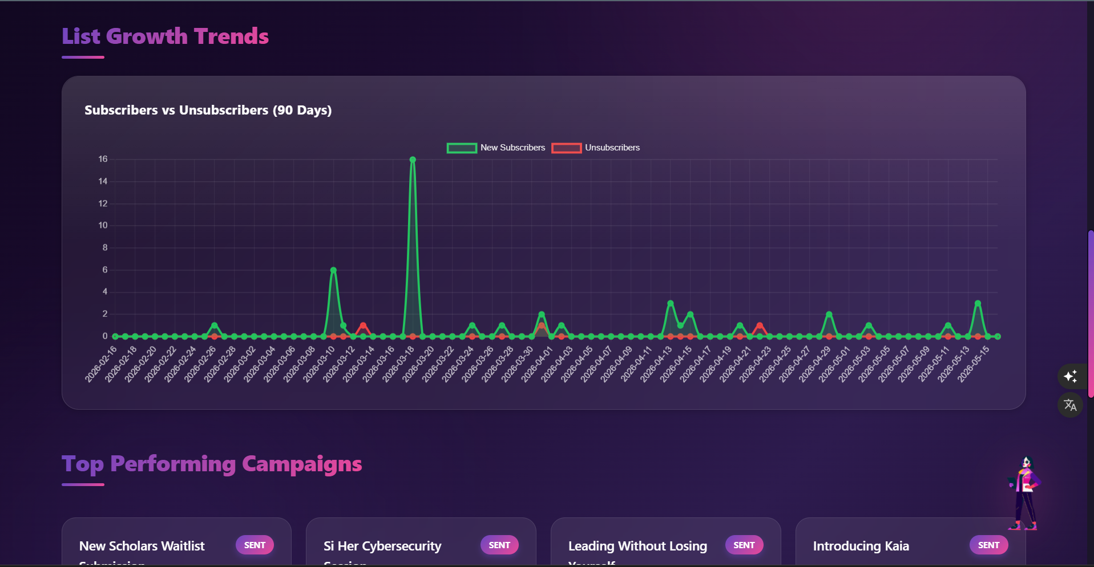
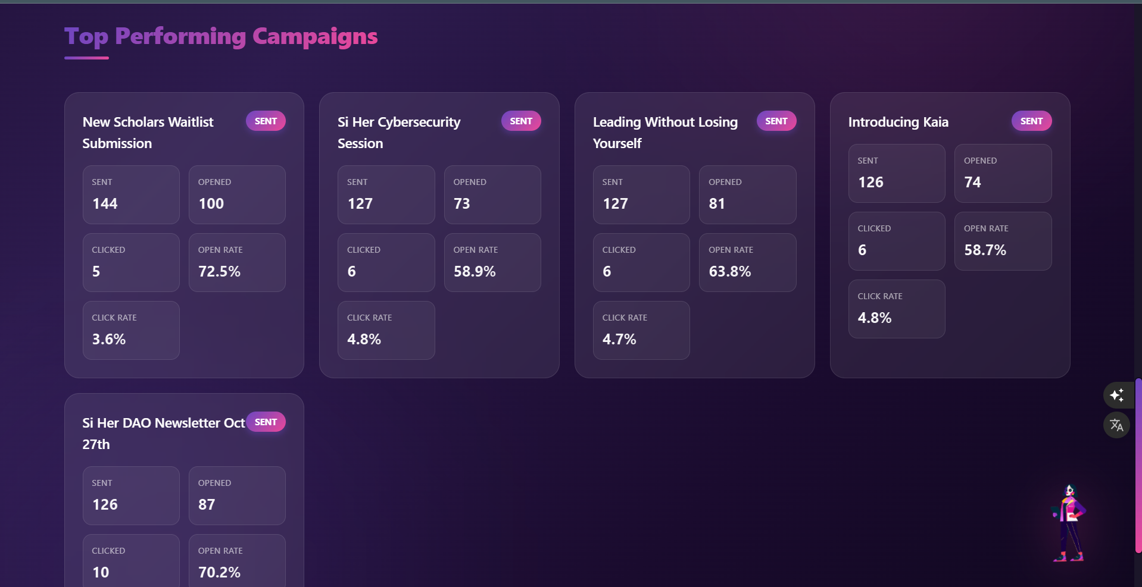
For a portfolio presentation, these can be paired with the live dashboard screenshots from the LinkedIn and Email views shown in the project context.

Portfolio-Ready Summary
SI3 Analytics Dashboard is a production-oriented analytics system for growth and email performance reporting. It turns LinkedIn exports and Loops webhook events into interactive dashboards, and it ships with a Docker-based deployment path so the stack can be reproduced consistently in development or production.

